Email Server

Lab

DNS and Email Server Configuration

A mail server (sometimes also referred to an e-mail server) is a server that handles and delivers e-mail over a network, usually over the Internet. A mail server can receive e-mails from client computers and deliver them to other mail servers. A mail server can also deliver e-mails to client computers. A client computer is normally the computer where you read your e-mails, for example your computer at home or in your office. Also an advanced mobile phone or Smartphone, with e-mail capabilities, can be regarded as a client computer in these circumstances.

**SMTP and POP3 server**

when you press the "Send" button in your e-mail program (e-mail client) the program will connect to a server on the network / Internet that is called an SMTP server. SMTP is an acronym for Simple Mail Transfer Protocol and it is a protocol that is used when e-mails are delivered from clients to servers and from servers to other servers.

When you download e-mails to your e-mail program the program will connect to a server on the net that is known as a POP3 server. A POP3 server uses a protocol named POP3 for its communication. That is the reason why it is called a POP3 server and POP3 is an acronym

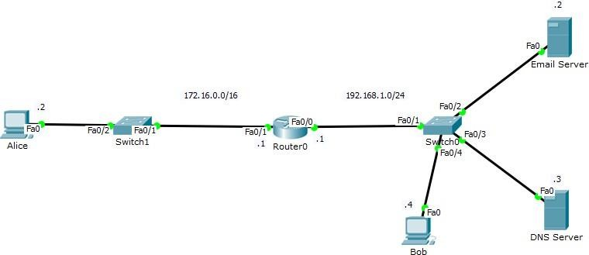for Post Office Protocol version 3.

Figure 1

**Refer to figure 1,**

# Task 1, IP to Router

Router>enable

Router# configure terminal

Enter configuration commands, one per line. End with CNTL/Z. Router(config)#interface Fa0/0

Router(config-if)#ip address 192.168.1.1 255.255.255.0 Router(config-if)#no shutdown

Router(config-if)#exit Router(config)#interface Fa0/1

Router(config-if)#ip address 172.16.0.1 255.255.0.0 Router(config-if)#no shutdown

Router(config-if)#exit

# Task 2, IP to PC & Server

Configure IPs on the PCs and Servers making sure to enter the IP for DNS Server as 192.168.1.3. Configure the DNS Server with an A Record (Address Record) entry for gmail.com (As shown in figure 2).

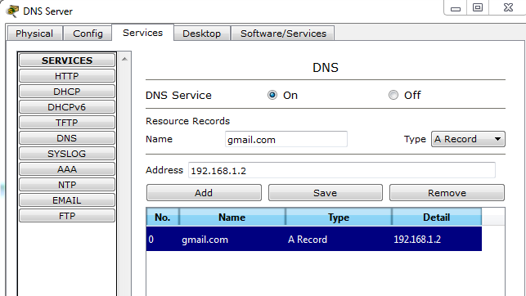

Figure 2

# Task 3, Making of Domain & User ID’s

Configure the Email Server; create a domain for gmail.com and User IDs for Alice & Bob (As shown in figure 3).

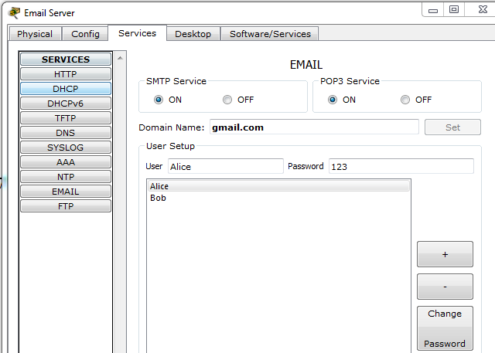

Figure 3

# Task 4, Users Configuration

Open the Email Settings on Alice and Bob and configure them (As shown in figure 4 & 5).

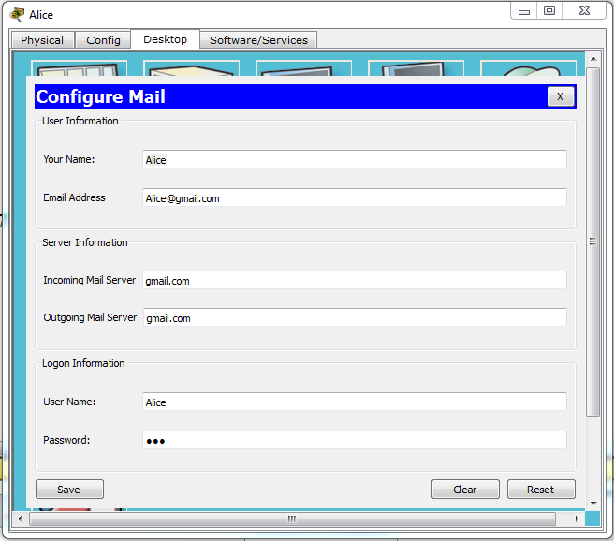

Figure 4

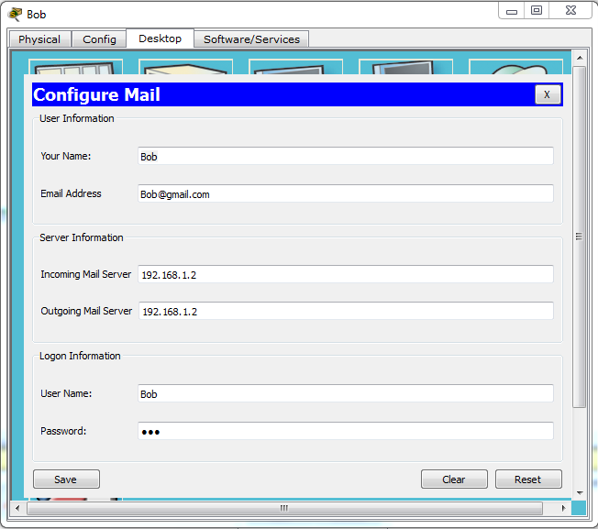

Figure 5

# Task 5, Sending an Email from Alice

Send a Test Email to Bob from Alice (As shown in figure 6)

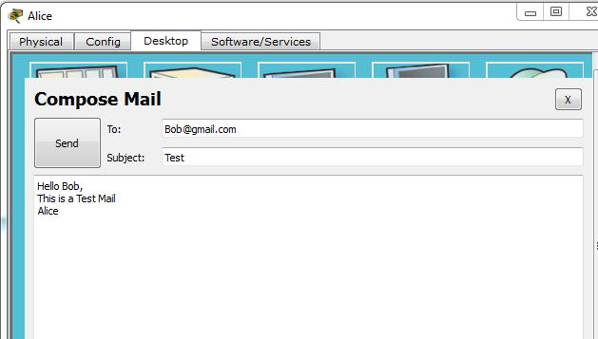

Figure 6

# Task 6, Receiving an Email on Bob

Now receive the email from Alice on Bob (As shown in figure 7)

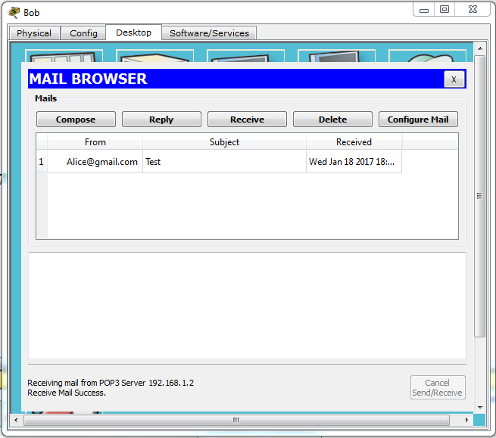

Figure 7

# Lab-11 Exercise:

Design a network as your teacher will assigned you in the lab.